Heroku account screen shot that has sample application installed on it

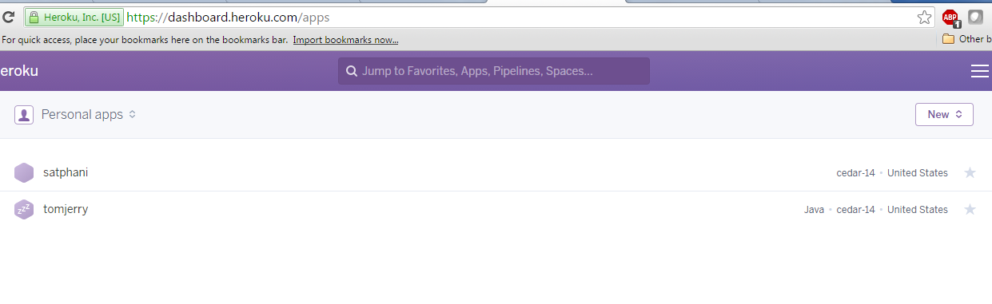

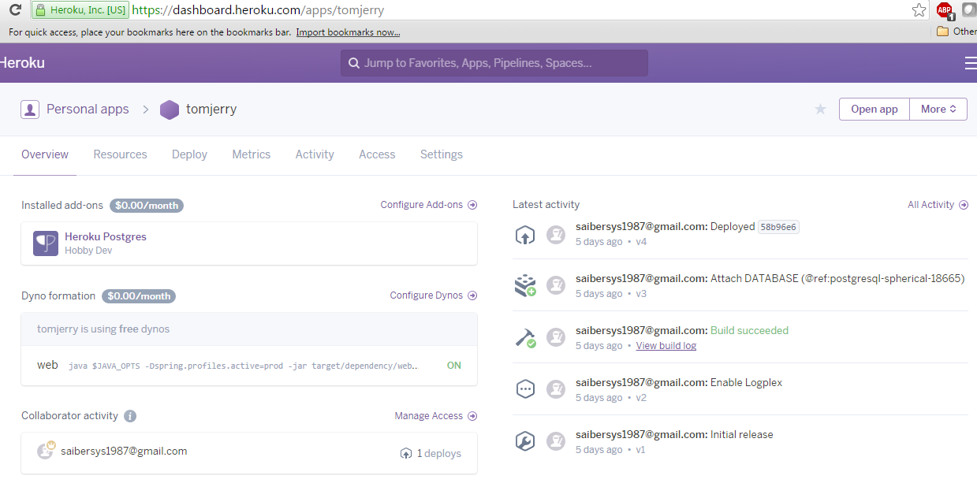

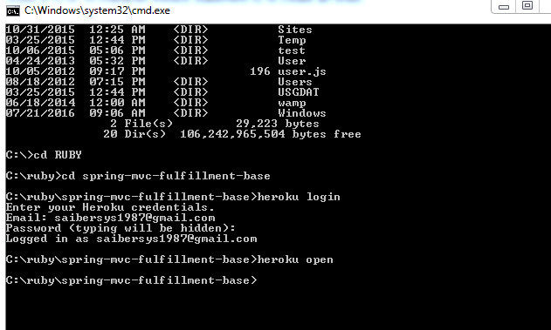

Below is the screenshot of tomjerry (heroku) application before the integration. It has only one order.

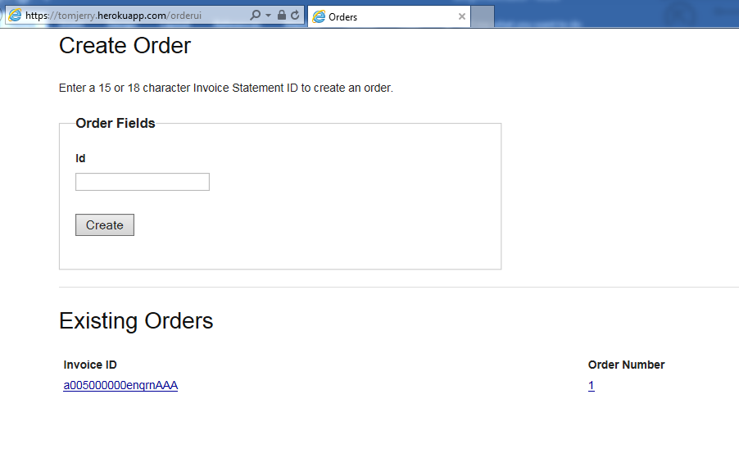

Below is the screenshot of invoice that is in open status. If we change the status to closed, then trigger will fire, calling the apex integration task which will send this data to heroku application. In application, new order ID will be created for the corresponding invoice and that ID will be sent back to the salesforce application. Then OrderId field will be populated with the ID in salesforce. Below are the series of screen shots.

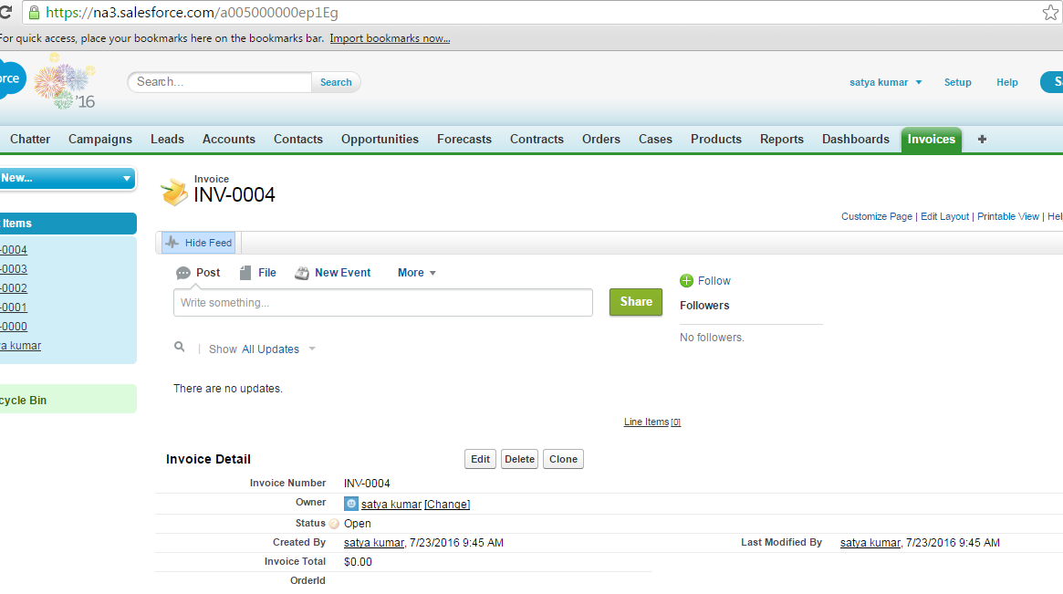

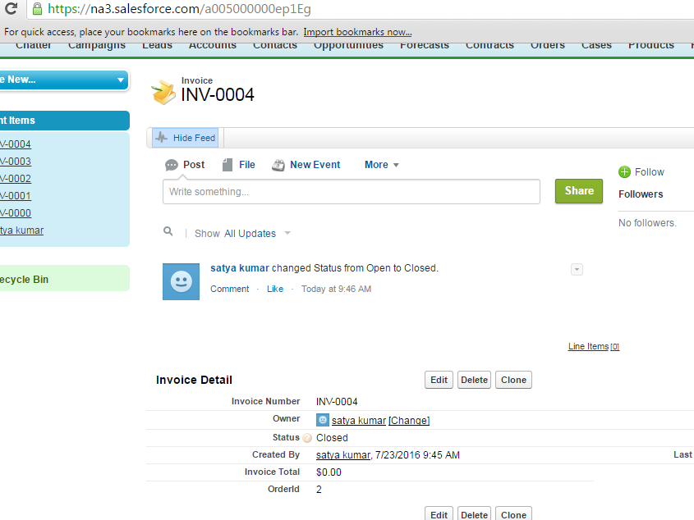

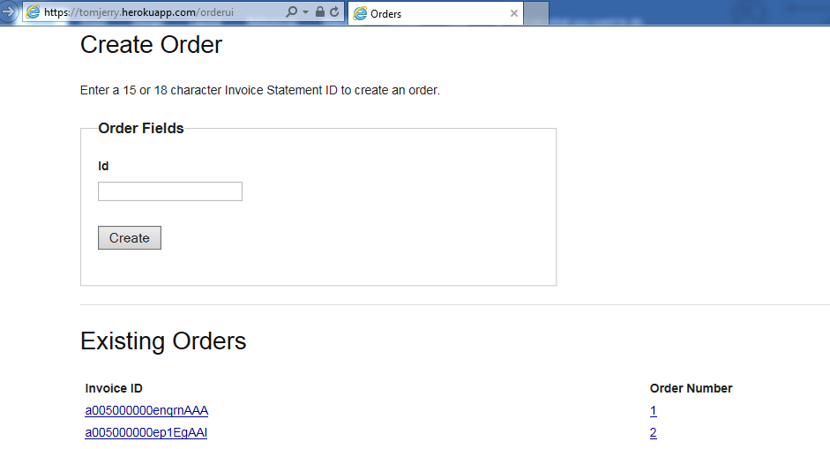

Apex class that was used for integration

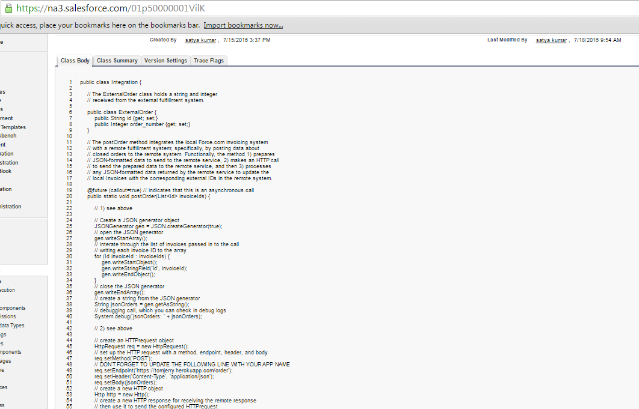

Apex trigger that calls the apex class when status changes from open to close

